Dear Dewey,
We have received the reports from our advisors on your manuscript, "Modeling the effect of convex upward deformation and horizontal sectioning on paleolimnological data", submitted to Journal of Paleolimnology.
Based on the advice received, we have decided that your manuscript can be accepted for publication after you have carried out the corrections as suggested by the reviewer(s). You will find the comments of Reviewer #1 below and those of Reviewer #2 attached here in the Editorial Manager System. As you revise, please follow JOPL style closely, i.e. no periods at the end of Table headers or figure legends. And use journal abbreviations throughout in the References. Please also put figure legends on a page separate from the figures.
Figure and table legends were added on a separate page; journal abbreviations were used instead of full journal names; periods were removed from the end of table and figure legends.
One additional thing. I recall that Glew et al. (2001) addressed sediment "compression" during coring. As I remember, the point was that sediment, with fluid-filled pore spaces, cannot be "compressed," so if you drive 1 meter, and collect only 90 cm, for example, it is because not all sediment was collected. This was attributed to a "wave front" that pushed sediment aside, ahead of the core barrel. Anyway, I believe they recommend using "core shortening." OK, we look forward to receiving the revised version.
Incorrect references to “compression” were removed or clarified.
Attached, please find the reviewers' comments for your perusal.
You are asked to carefully consider the reviewers' comments which are attached, and submit a list of responses to the comments. We do not necessarily expect that you will agree with all the comments, but we would like to receive justifications for any comments you decide should not be incorporated.
"Please submit your revision as an editable Word file. Please do not include active links to your references in the text of the revision".
Please also submit your response to the reviewers' comments online as submission item.
We are looking forward to receiving your revised manuscript
within 120 days.
With kind regards,
Mark Brenner, Ph.D.
Editor in Chief
Journal of Paleolimnology
COMMENTS TO THE AUTHOR:
Reviewer #1: A short paper that provides a mathematical model for evaluating convex-up deformation in sediment cores. While the paper adequately models the deformation I felt that some more practical advise might be reasonable to expect. For example, based on the deformation, once a horizontal slice of sediment has been collected how much of the periphery (outer diameter) could be removed from the slice to minimize the contamination of the sample caused by deformation? Is there other advise/guidance the authors provide?
We added the suggestion that the outer few millimeters of sediment be discarded in the conclusion, and the observation that the areas that contain the highest amount of deformation are in the outer few millimeters of the section in the model. It may be possible to quantify how much is enough, but we feel that since our model is an approximation, this measurement would change our suggestion of ‘a few millimeters’ little.
Minor points
Consider reversing order of 2nd and 3rd sentence in the abstract to have the methods come before the results.
We choose not to revise this, as our 3rd sentence contains more results, and reversing the sentences would not achieve the desired result. We feel our methods are adequately summarized in the first sentence, but would be happy to revise should a more specific revision be suggested.
Intro, ln 2, Glew et al. 2001 is a good reference here. They also discuss sediment bypassing which sometimes is assumed to be compression.
The Glew et al. 2001 reference was added at line 2. We corrected the statement about sediment bypassing which we had previously referred to as compression.
" ln 27, spelling of function.
The spelling of ‘function’ was corrected
" ln 37, whose function is proposed, yours or Kegwin et al's?
Kegwin et al. (1998) proposed the function. This was clarified in our revised manuscript.
" ln 57, avoid first person, instead "It is suspected . . ." also line 4, next page.
In this paper we have chosen to primarily use the first person active voice. Changing these two instances would lead to an inconsistent tone of the paper. We would be happy to remove all of our first person references if requested, however we feel strongly that the manuscript is more compelling with first person reference left intact.
In second methods, of the photos used, were all cores collected using the same technique?
The coring method for each photo was added to Table 1.
Methods ln 32, when a number is <10, spell it out.
This was fixed in the methods section.
Bottom of page 3 sediment bypassing as well as compression, and delete last phrase in this sentence.
“Compression” was changed to “more complex deformation”, as this more generically fits our intent.
5th line from bottom of page 4: 'inspired' is an odd choice of word.
We changed “inspired by” to “designed to resemble”, as this more accurately describes our intent.
For results, start second paragraph with "Slice thicknesses of 0.1 . . . "
This was updated in the revised manuscript.
The conclusions introduce new information about a specific type of corer, which should be mentioned earlier and then is not needed in the conclusions.
This statement was moved to the results section.
Acknowledgments: Did the entire department offer comments> Instead, perhaps there are a few individuals who should be mentioned.
We updated this section to remove the awkward phrasing and acknowledge the reviewers’ contributions.
The Menounos et al. 2005 reference was not cited.
The reference was removed
Reviewer #2: see attached comments
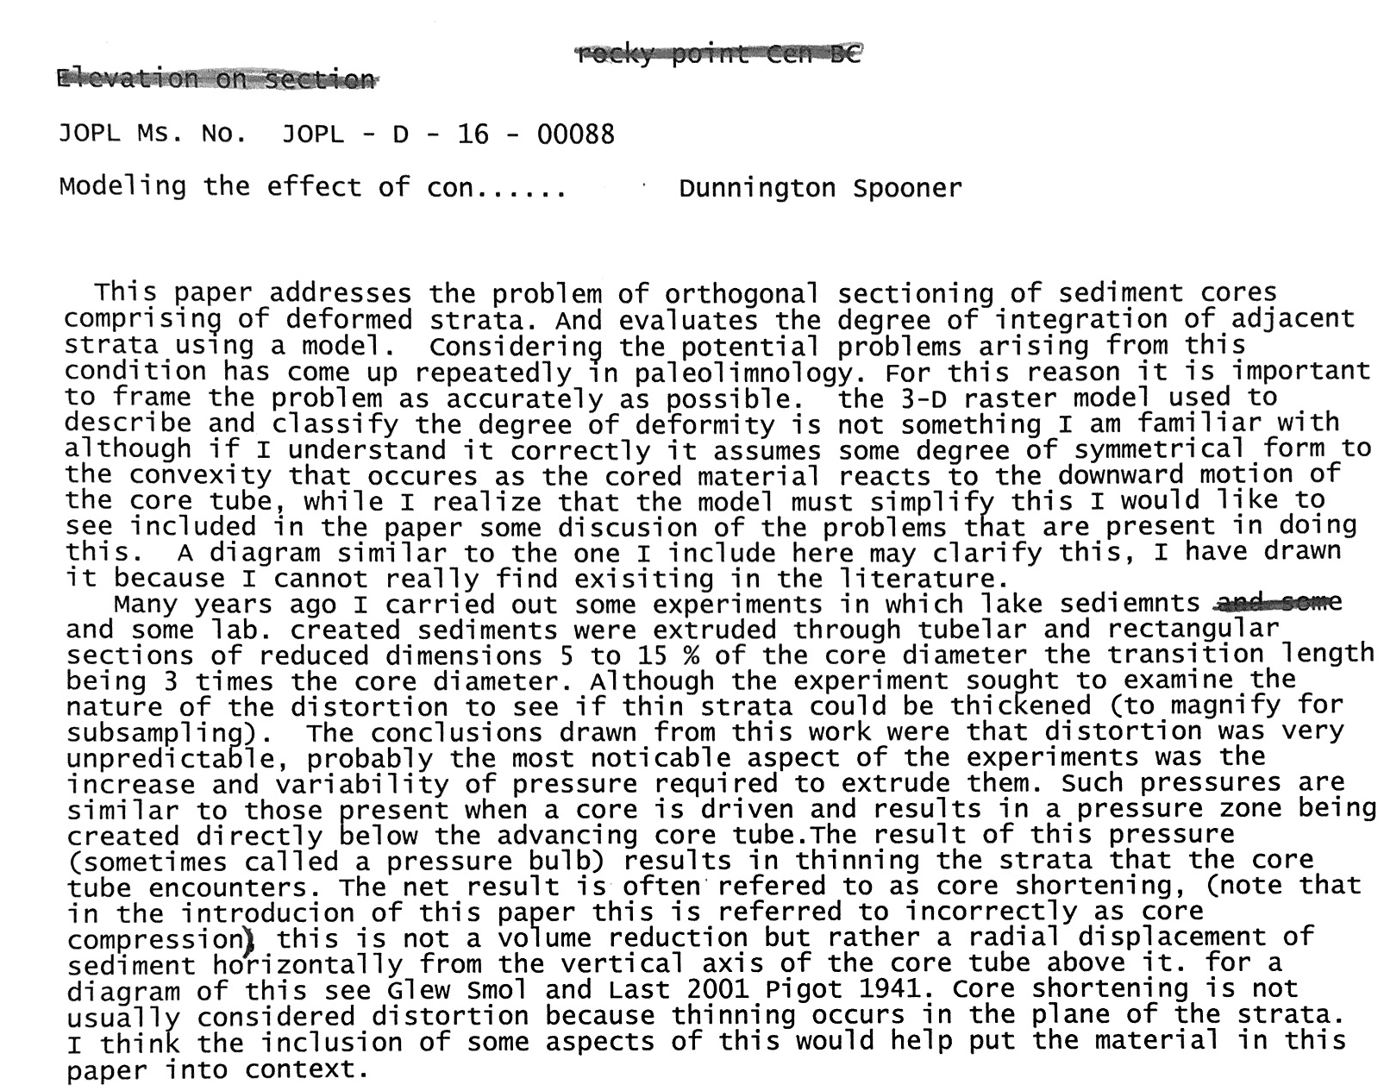

We thank the reviewer for his detailed artwork and careful consideration of the manuscript. As a result of these comments, we have incorporated the following changes into the manuscript:
- Corrected the statement which incorrectly referred to core shortening as compression and referred readers to Glew et al. (2001) for a discussion of forces acting on sediments during coring.
- Added the reveiwer’s language of “integration of adjascent strata” to the methods section to more clearly describe our model.
- Added a statement in the conclusion recognizing the limitations of an idealized model applied to a complex deformation environment, and a statement in the results recognizing the complex nature of deformed sediment.
- Generated a new figure attempting to replicate the reviewer’s schematic of how multiple layers may become incorporated into a single horizontal section.
- Added a statement at the beginning of the second introduction paragraph referencing this figure.
The reviewer’s figure is far more detailed than the one we were able to construct, but the supplied figure is not quite up to publication standard and we do not feel comfortable asking a volunteer anonymous reviewer to put more time into a very elaborate figure.
